## Steps to create hybrid topology.

1. Design your topology
2. Create the Physical Topology
3. Assign IP Addresses
4. Verify Connectivity

|  |  |  |
| --- | --- | --- |
| s.no | device | Model name |
| 1 | PC | PC |
| 2 | switch | PT-Switch |

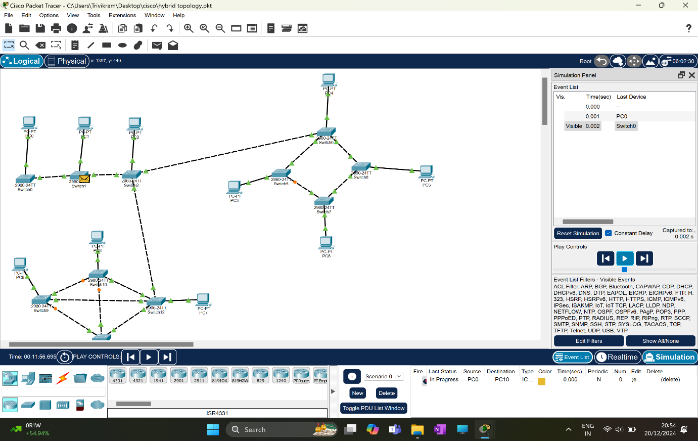

## Observations

1. **Distributed Control:** Without a central core switch, control is distributed among multiple switches. This can make management more complex, as there's no single point of control.
2. **Increased Redundancy:** Depending on the specific configuration, a hybrid topology without a core switch can offer increased redundancy. If one switch fails, traffic can be rerouted through other switches.
3. **Scalability:** The scalability of the network might be limited compared to a topology with a core switch, as adding new devices may require careful planning and configuration.
4. **Performance:** The performance of the network can be affected by the load on individual switches and the efficiency of the routing protocols used.
5. **Troubleshooting:** Troubleshooting can be more challenging without a centralized point of control. However, Packet Tracer's simulation tools can help identify and resolve issues.

Thank you .